Course Methods test 2 Year 12

Student name: ________________ Teacher name: ________________

Task type: Response

Time allowed for this task: ___40________ mins

Number of questions: ____8_______

Materials required: Calculator with CAS capability (to be provided by the student)

Standard items: Pens (blue/black preferred), pencils (including coloured), sharpener, correction fluid/tape, eraser, ruler, highlighters

Special items: Drawing instruments, templates, notes on one unfolded sheet of
A4 paper, and up to three calculators approved for use in the WACE examinations

Marks available: ___41___ marks

Task weighting: _10___%

Formula sheet provided: Yes

Note: All part questions worth more than 2 marks require working to obtain full marks.

Q1 ( 3 & 3 = 6 marks) (3.2.9)
Determine in terms of for the following. Show all working.
- and when .

- and when .

Q2 (3 & 2 = 5 marks) (3.2.22, 3.2.5)
A car travels in a straight line from the origin, initially at rest, with constant acceleration with time in seconds.
- Determine the distance from the origin at seconds?

- What is the velocity of the car at seconds?

Q3 (2 marks) (3.2.19)
Determine the exact area between and the axis from to .

Q4 (2, 2 & 3 = 7 marks) (3.2.18)
A factory produces electric vehicles. The total number, , that the company has produced months after production commenced is such that:
Determine the number produced in
- The first 6 months

- The third month

Determine the minimum number of months required to produce:
- 10000 vehicles.

Q5 (5 & 3 = 8 marks) (3.2.20)
- On the axes below, sketch the following graphs: and . Indicate on your sketch coordinates(one decimal place) of any stationary points, and label their nature, and of any points where the graphs intersect each other.

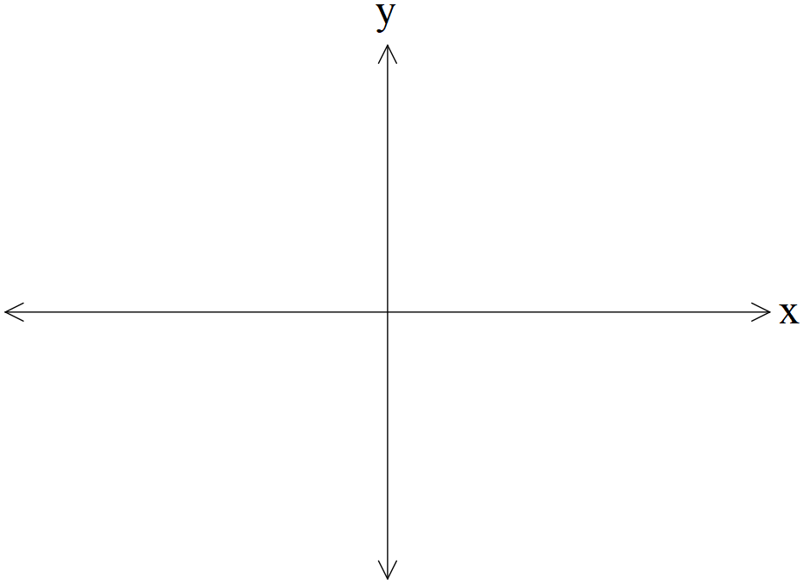

- Determine the exact area between and .

Q6 (2 & 2 = 4 marks) (3.1.3, 3.1.4)
The number of kangaroos, in a particular site that have developed disease W are increasing such that with the time in years. There are initially 2300 kangaroos with the disease.
- Determine the number of kangaroos with disease W in 5 years’ time.

- Determine the time taken to triple the number with the disease in years to one decimal place.

Q7 (4 marks) (3.2.16)

Consider the function such that and .
Determine the rule for the function .
Q8 (5 marks) (3.1.15)

Consider the function where are constants.

Below is a graph of (Note: diagram is not drawn to scale)

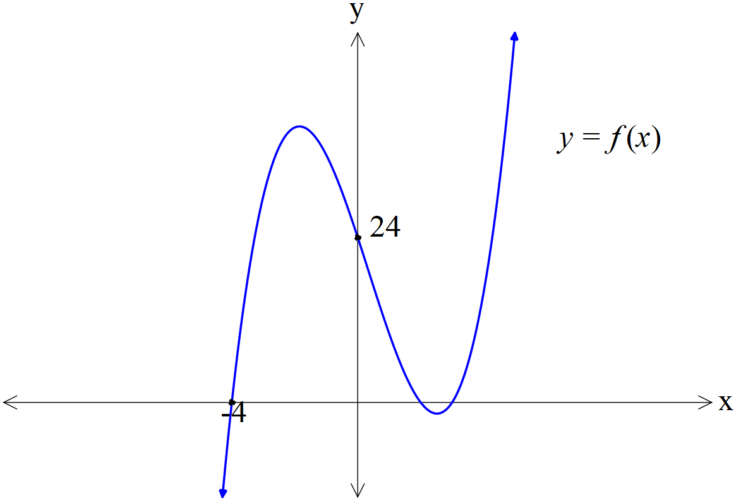

There is an intercept at , intercept at and .
There is an inflection point at .

Determine the exact values of .

